Cancer viscoelasticity: A dynamic compression assay for tumor spheroids characterization
Rosalia Ferraro, Sergio Caserta*
Università degli Studi di Napoli Federico II, Piazzale Vincenzo Tecchio, 80, 80125 Napoli NA
*Corresponding author E-Mail: sergio.caserta@unina.it

1.Introduction
Cancer is a complex, heterogeneous and multifactorial disease, that is a leading healthcare problem worldwide. Several experimental and clinical studies of malignant neoplasms indicate that invasive growth and metastasis are the main manifestations of tumor progression, strongly influenced by the microenvironment, in particular chemical [1, 2] and mechanical [3-5] stresses.
Deep biomechanical differences between healthy and tumoral tissues exist, in fact, malignant transformations are associated with significant changes in the cytoskeleton structure and cell-cell interactions. Understanding the mechanical behavior and cellular organization is not easy. A novel approach here proposed is based on the analysis of living tissues as bio-soft matter, based on typical rheological models traditionally developed for non-bio complex fluids (polymers, surfactants, foams, etc.) [6].
Our work is focused on the development and validation of an innovative methodology to measure the role of external (bio-) mechanical stimuli on the capacity of tumors to invade the surrounding healthy tissue, using a 3D model of not-vascularized tumor: cell spheroid [7-9]. Tumoral spheroids are tightly bound cellular aggregates that tend to form when cells are growth in a nonadherent environment. To measure the mechanical response of the system, a dynamic compression was applied to the spheroids. Shape evolution of spheroids under controlled compression was modelled using standard springs and dampers rheological models available in the literature in order to estimate viscosity and elastic moduli of the system, quantifying the cell adhesion and invasive potential of different types of tumors.
2. Methods
2.1. Cell culture
A non-tumoral cell line (NIH/3T3) was used as control in the mechanical assay. Cells were cultured in their standard growth medium in 2D monolayers under the typical cell culture conditions, at 37°C in a humidified atmosphere (5% CO2). In detail, NIH/3T3 mouse fibroblasts cells were cultured in Dulbecco’s Modified Eagle’s Medium (DMEM) supplemented with 10% (v/v) Fetal Bovine Serum (FBS), 1% (v/v) antibiotics (50 units/mL penicillin and 50 mg/mL streptomycin) and 1% (v/v) L-glutamine.
2.2. Spheroid formation
Spheroids were produced using the “agarose multi-well plate method”. Specifically, 1% agarose solution was prepared by dissolving agarose powder (E AGAROSE, Conda, Cat nº 8100) in water at 200°C for 20’ using a magnetic stirrer to homogenize the solution. Then, agarose solution was rapidly pipetted in 200 μl aliquots into the wells of a 48-well culture dish under sterile conditions and allowed to cool down. By capillary, agarose solution rises along the walls of the wells, thus gelifying in a few minutes forming a hemi-spherical meniscus. The non-adhesive concave surface promotes the collection of cells in the meniscus and cell-cell adhesion establishment; this leads to the formation of cell aggregates that finally evolve in compact spheroids after an adequate incubation time, depending on cell type and concentration. Typically, 5-10 days (depending on cell line) are required to obtain compact spheroids of adequate size.

2.3. Image and Chemotaxis Data Analysis
The dynamic evolution of tumoral spheroids was quantified by measuring different morphological parameters, i.e., area (A, µm²) and diameter (d, µm). Spheroids images were analyzed using a commercial image analysis software (Image Pro Plus 6.0). Variations in the diameter as measured in the direction orthogonal to the compression was defined as strain $\left(ε=\frac{d_{i}-d_{0}}{d_{0}}\right)$, and plotted as function of time, during the compression test.
2.4. Preparation of assay
In our compression assay, spheroids were placed in a Petri-dish, filled with Phosphate-Buffered Saline (PBS), and mechanical stress (σ, kPa) were applied to spheroids by using coverslip glasses. Images were acquired in time lapse using an inverted microscope (Zeiss Axiovert 200M) with a delay time of 2 seconds, in order to follow the spheroid deformation during the creep test experiment.
3. Results and discussion
Representative phase contrast microscopy images of NIH/3T3 spheroids are reported in Figure 1, comparing the undeformed spheroid with final image of, corresponding to the steady deformation. It is evident that spheroid size significantly increases after compression, proving the phenomena can be measured with high precision.
Figure 1. Representative phase-contrast microscopy images showing the morphological response of NIH/3T3 spheroids before (left) and after (right) mechanical stress.
To quantify spheroids morphological response, evolution of deformation, ε, is reported as function of time, t, in Figure 2, and compared to models inspired from standard non-bio soft matter systems. As shown, deformation value increases ~20% as response of mechanical stress. In addition, fitting experimental data using standard springs and dampers rheological models, available in the literature, viscosity, elastic modulus and relaxation time of the system can be estimated. For example, the relaxation time, intended as the time necessary for the cell reorganization, in this experimental condition, is ~50s, corresponding to the onset of linear plateau in the deformation.
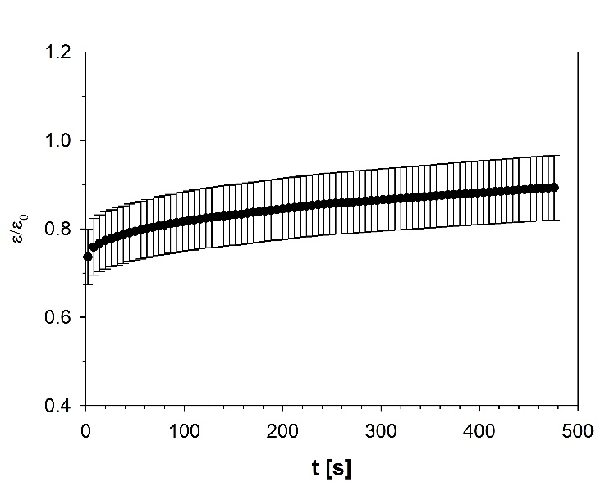
Figure 2. Creep test conducted at σ~54 kPa.
4. Conclusions
In this paper, an innovative experimental assay aimed to quantify spheroid morphological response to a mechanical stress is proposed, in order to characterize rheological property of the system to be related to invasiveness of tumoral mass. The methodology is based on a mechanical analysis of living tissues as bio-soft matter.
Tumour spheroids were subjected to a stress by using a coverslip glass and observed by means of Time-Lapse video microscopy. The approach here proposed represents an innovative technique to investigate complex biological systems, such as cancer. The possibility to quantify differences in invasiveness of cancer cell types represents a key advancement that can be implemented in personalized medicine applications.
References
[1] R. Ferraro, F. Ascione, P. Dogra, V. Cristini, S. Guido, S. Caserta, Diffusion-induced anisotropic cancer invasion: a novel experimental method based on tumour spheroids, AIChE Journal n/a(n/a) e17658. https://doi.org/https://doi.org/10.1002/aic.17678.
[2] C.K.N. Li, The glucose distribution in 9L rat brain multicell tumor spheroids and its effect on cell necrosis, cancer 50(10) (1982) 2066-2073.
[3] G. Helmlinger, P.A. Netti, H.C. Lichtenbeld, R.J. Melder, R.K. Jain, Solid stress inhibits the growth of multicellular tumor spheroids, Nature biotechnology 15(8) (1997) 778-783.
[4] F. Montel, M. Delarue, J. Elgeti, D. Vignjevic, G. Cappello, J. Prost, Isotropic stress reduces cell proliferation in tumor spheroids, New Journal of Physics 14(5) (2012) 055008.
[5] M. Delarue, F. Montel, D. Vignjevic, J. Prost, J.-F. Joanny, G. Cappello, Compressive stress inhibits proliferation in tumor spheroids through a volume limitation, Biophysical journal 107(8) (2014) 1821-1828.
[6] M.S. Steinberg, Reconstruction of tissues by dissociated cells, Science 141(3579) (1963) 401-408.
[7] D. Drasdo, S. Höhme, A single-cell-based model of tumor growth in vitro: monolayers and spheroids, Physical biology 2(3) (2005) 133.
[8] F. Hirschhaeuser, H. Menne, C. Dittfeld, J. West, W. Mueller-Klieser, L.A. Kunz-Schughart, Multicellular tumor spheroids: an underestimated tool is catching up again, Journal of biotechnology 148(1) (2010) 3-15.
[9] T.-M. Achilli, J. Meyer, J.R. Morgan, Advances in the formation, use and understanding of multi-cellular spheroids, Expert opinion on biological therapy 12(10) (2012) 1347-1360.

